**Open BCI Data Collection Protocol V3**

Experiment Setup:

* 16 Channel Open BCI Cyton+Daisy Board
  + [Ultracortex Mark IV Cap](https://docs.openbci.com/AddOns/Headwear/MarkIV/#3d-printed-parts-1)
  + Input Channel Locations: Fp1**(1)**, Fp2**(2)**, C3**(3),** C4**(4)**, P7**(5)**, P8**(6)**, O1**(7)**, O2**(8)**, F7**(9)**, F8**(10)**, F3**(11)**, F4**(12)**, T7**(13)**, T8**(14)**, P3**(15)**, P4**(16)**
  + Reference Channel Location Cz
* **Sampling Rate: 125 Hz**
* There would be 5 different presentations.
* Link to presentations: <https://drive.google.com/drive/folders/1_bix40FwXSk2BHCyfslTWR8fAyK18dsF?usp=sharing>
* There should at least be 15 participants for the data collection.
* Estimated time burden for each participant: 207 seconds (approximately 3 and a half minutes)
* Please ensure the experiment is done in a quiet and distraction-free environment.

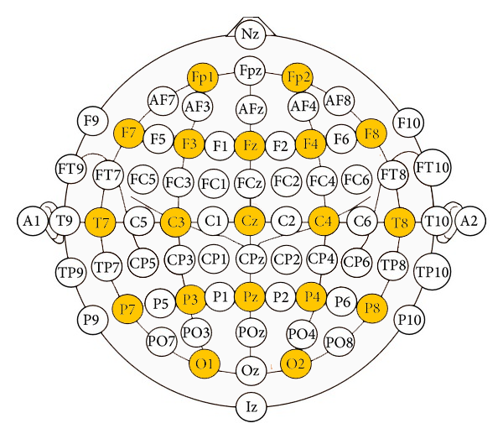

Experiment Procedure:

* ~~A participant should be randomly assigned 1 presentation out of the 5 present.~~
* Each presentation should be randomly assigned to 3 participants.
* Please indicate the presentation number in the name of the data file
* The image and shape slides should be shown for 6 seconds and the blank slides should be shown for 3 seconds. The PowerPoint should be set to transition automatically.
* The **exact** start timestamp of the presentation should be noted and reported.